AN AUTOMATED LIVE STREAMING AND UPLOADING VIDEO RECORDING ASSISTANCE SYSTEM USING REAL-TIME BASED OBJECT DETECTION, TRACKING, AUDIO RECOGNITION TECHNIQUES

Ms. Deeksha Rai
UG Scholar, Department of Artificial Intelligence, SET, Jain Global Campus, Jain (Deemed-to-be University), Kanakapura Road, Bangalore, Karnataka, India.
raideeksha5079@gmail.com
Yohannes tesfaye sida
UG Scholar, Department of Artificial Intelligence, SET, Jain Global Campus, Jain (Deemed-to-be University), Kanakapura Road, Bangalore, Karnataka, India.
yohannestesfayejo@gmail.com
Dr. N. Satheesh
Department of Artificial Intelligence
SET, Jain Global Campus, Jain (Deemed-to-be University)
Kanakapura Road, Bangalore, Karnataka, India.
nsatheesh1983@gmail.com, https://orcid.org/0000-0002-7521-2599
Sumana Avula
UG Scholar, Department of Artificial Intelligence, SET, Jain Global Campus, Jain (Deemed-to-be University), Kanakapura Road, Bangalore, Karnataka, India.
20btrca039@jainuniversity.ac.in
Dr. Janaki
Department of Artificial Intelligence
SET, Jain Global Campus, Jain (Deemed-to-be University)
Kanakapura Road, Bangalore, Karnataka, India.
k.janaki@jainuniversity.ac.in
Emmanuel Kasongo
UG Scholar, Department of Artificial Intelligence, SET, Jain Global Campus, Jain (Deemed-to-be University), Kanakapura Road, Bangalore, Karnataka, India.
20btrmt021@jainuniversity.ac.in

Abstract— The Automatic Video Recording Assistant System is a software solution that helps users to record video content with ease. It is designed to make the video recording process simpler and more efficient. The system is built with advanced features that enable users to set up recording schedules, select recording devices, and customize their settings.
Keywords— Real-time Object Detection, Object Tracking, Audio Recognition, Cloud Storage, YOLOv4 Algorithm, AWS S3.

Introduction
The system is perfect for individuals, businesses, and organizations that need to record video content frequently. It does away with the necessity for manual recording, which is error-prone and time-consuming. With the Automatic Video Recording Assistant System, users can focus on creating high-quality video content while the system takes care of the recording process.
This paper aims to develop an automated video recording assistant system with real-time object detection and tracking, audio recognition, and automated live streaming and uploading to cloud storage. The system utilizes advanced algorithms for object detection and tracking, allowing it to accurately detect and track objects in real-time. Audio recognition is also integrated, enabling the system to trigger the recording option automatically without the need for human intervention. The system is designed to automate the video recording process and provide users with a hassle-free experience by live streaming and uploading the recorded footage directly to cloud storage. The end product will significantly enhance the efficiency of video recording, making it more accessible and convenient for users, while also minimizing the need for human intervention.

Objective of the paper
This paper aims to automate video recording in industries such as sports and wildlife documentaries. Using deep learning algorithms and computer vision techniques, the process is fully automated, improving video quality and reducing human error. Real-time tracking and object following ensure that recordings are always in focus and accurately framed, reducing the need for post-production editing. This paper has the potential to revolutionize video recording in various industries, making it more efficient and accessible.

PROPOSED SYSTEM
The proposed system in this paper is an Automatic Video Recording Assistant System, which is a software solution designed to simplify and enhance the video recording process. The system incorporates advanced features to enable users to set up recording schedules, choose recording devices, and customize settings. The primary objectives of the paper are:
1. Automation with Real-Time Object Detection and Tracking: The system tracks and detects objects in real time by using sophisticated algorithms. By ensuring that the recording remains focused on and precisely tracks objects, this feature improves video quality and lessens the need for post-production editing.
2. Audio Recognition: The system incorporates audio recognition technology to automatically trigger the recording option based on specific audio signals. This eliminates the need for manual intervention, ensuring that important moments are captured without missing any footage.
3. Automated Live Streaming and Cloud Storage: The system is designed to automate the video recording process and provide hassle-free experiences for users. It includes features for live streaming and uploading recorded footage directly to cloud storage, specifically using Amazon Web Services (AWS) S3. This enhances the efficiency of video recording and makes it more accessible and convenient.
The paper aims to address the needs of various industries, such as sports and wildlife documentaries, by improving video quality, reducing human errors, and making the video recording process more efficient. The proposed system also has the potential to revolutionize video recording in different domains, making it more accessible and user-friendly.
Algorithms like YOLOv4 for object tracking and detection, Ya M Net for audio recognition, and AWS S3 for automated video uploading and live streaming are used in the implementation. Python programming is used in the system's design to make it compatible with a variety of operating systems, including Windows, macOS, and Android. To verify the overall quality and dependability of the system, a variety of testing methodologies are used during the testing phase, including unit, integration, black-box, white-box, acceptance, regression, performance, and exploratory testing.

WORKING PRINCIPLES OF PROPOSED ALGORITHM
A. Object Detection and Tracking Algorithm
▪ Object detection is just the process of locating and identifying every known object in a scene.
▪ Identifying the existence of an object in a series of images and potentially pinpointing its exact location for identification is the task of object detection in videos.
▪ Object tracking is the problem of figuring out (estimating) the positions and other pertinent details of moving objects in image sequences.
▪ ▪ OR Locking onto a particular moving object or objects in real time is known as object tracking.

Yolo v4 Algorithm
Figure 3.1 illustrates that YOLOv4 is a cutting-edge model for object detection. This well-liked real-time object detection algorithm, which stands for "You Only Look Once," can identify objects in an image or a live video stream.
Step1 Improved Backbone: YOLOv4 uses a new backbone network called CSPDarknet53, which has improved feature extraction capabilities compared to previous backbones.
Step 2: Spatial Pyramid Pooling (SPP): SPP is a method that involves pooling operations on each of the grids that make up the input image, each of which is divided into different sizes. This increases YOLOv4's accuracy and enables it to detect objects at various scales.
Step 3: Mish Activation Function: Compared to other activation functions, Mish is a unique activation function that has been demonstrated to enhance the performance of deep learning models.
Step 4: Bag of Freebies (BOF) and Bag of Specials (BOS): By altering the training procedure, BOF and BOS are strategies used to enhance YOLOv4's performance.
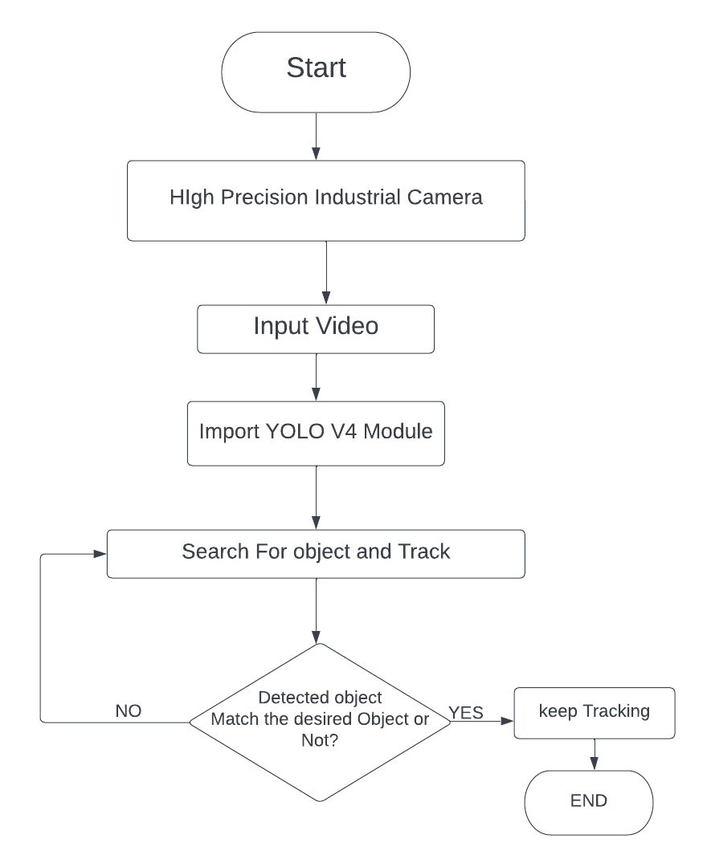
Fig 3.1 Flowchart of Object Tracking and Detection Flowchart Yolo V4 Flowchart

B. Audio Recognition Algorithm
As figure 3.2 shows In this paper, audio recognition technology is utilized to automate the video recording process. By recognizing a specific audio signal, the system triggers the recording option, eliminating the need for human intervention. This technology enables the system to start recording at precisely the right moment, capturing important footage that might have otherwise been missed. The use of audio recognition technology in video recording is an exciting advancement that can revolutionize various industries, from capturing live performances to security surveillance.
YaMNet Model
Google created YAMNet, or "Yet Another Music Recognizer," a pre-trained deep learning model for audio classification. It is intended to identify a broad range of auditory stimuli, such as human voices, animal sounds, musical instruments, and ambient noises.
Based on a deep convolutional neural network (CNN) architecture, the YAMNet model generates a probability distribution over 521 audio event classes from an input audio waveform. The AudioSet dataset, which includes millions of annotated audio clips from YouTube videos, is used to pre-train the model.
It accepts an audio waveform represented by a spectrogram as input. An illustration of a sound wave's amplitudes and frequencies over time is called a spectrogram. The YAMNet model uses a sequence of convolutional layers, global average pooling, and a fully connected layer to extract features from the spectrogram.
Step1:Input Preprocessing: The audio waveform is preprocessed to extract a spectrogram representation.
Step 2: Feature Extraction: The input spectrogram's features are extracted using convolutional layers.
Step 3: Global Average Pooling: To lower the dimensionality of the feature maps, a global average pooling layer is applied.
Step 4: Fully Connected Layer: A fully connected layer that maps the feature vector to a probability distribution across audio event classes receives the output from the global average pooling layer.
Step 5: Softmax Activation: A softmax activation function is applied to obtain the final probability distribution over the audio event classes.
Step 6:Inference: The model takes an input audio waveform, preprocesses it to obtain a spectrogram, feeds it through the model, and outputs a probability distribution over the audio event classes.
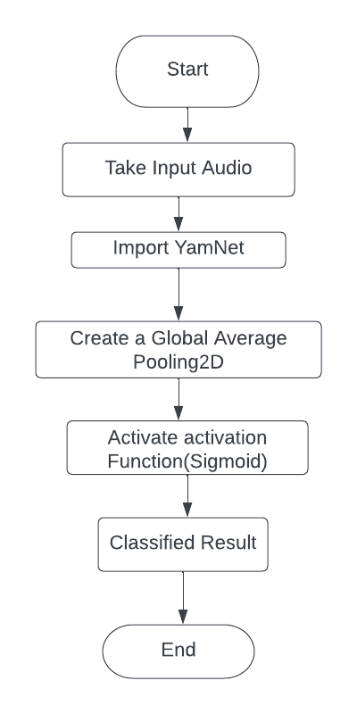
Fig 3.3 Flowchart of Audio Recognition
C. Automatic Video Uploading and live with AWS s 3
Step1Create an S3 bucket where you will store the live video recordings.
Step2 Configure your video recording device or software to stream the live video content directly to the S3 bucket. You can use an S3 endpoint URL to stream directly to S3 or use Amazon CloudFront to deliver the video stream from S3 to viewers.
Step3 Set up an Amazon CloudFront distribution to stream the live video content to viewers. You can use a CloudFront RTMP distribution to stream live video content or a HTTP distribution for non-live content.
Step4 Set the appropriate permissions and access controls on the S3 bucket to ensure that only authorized users can access the live video content.
Step5 Configure the CloudFront distribution to use the S3 bucket as its origin so that it can stream the live video content to viewers.
Step6 Start streaming live video content to the S3 bucket. The video content will be automatically stored in the S3 bucket and available for playback through the CloudFront distribution
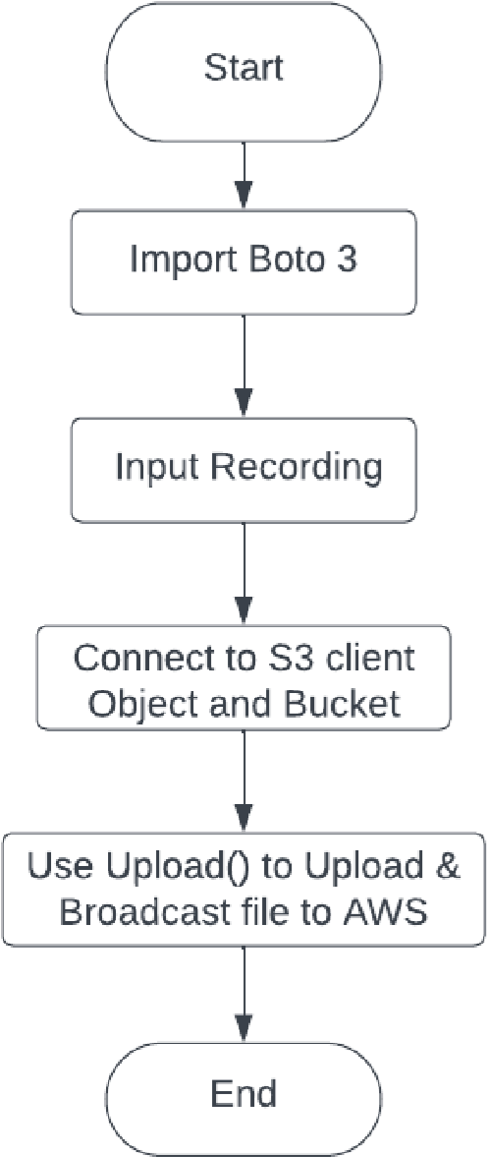
Fig 3.4 Automatic Broadcasting and Uploading top AWS
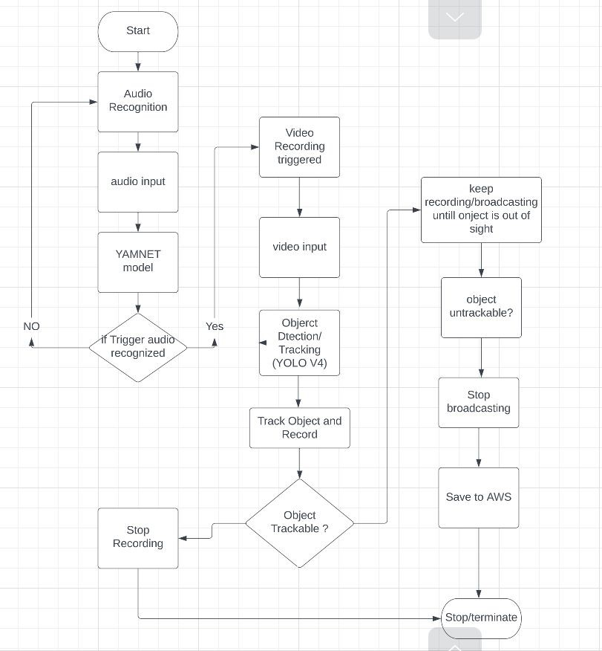
Fig.3.4 Overall flowchart of video recording assistive system

Overall functionality of video recording assistive system. In this paper first audio recognition algorithm applied if object recognized video recording started and recorded video is deployed to cloud storage automatically.
The Automatic Video Recording Assistant System described in the paper has various applications across different domains. Here are some potential applications:
1. Education (Lecture Recording): The system can be used in educational institutions to automate the recording of lectures and presentations. The integration of augmented reality (AR) technology for lecture video recording, as mentioned in one of the literature survey papers, can enhance the learning experience.
2. Sports Training (Basketball Training): Sports training scenarios can utilize the system's camera-based deep learning AI assistant for basketball training. It can record and evaluate players' on-court actions, which benefits players' and coaches' skill development.
3. Security Surveillance Object Detection and Tracking: In security surveillance systems, the real-time object detection and tracking features can be used. By automatically identifying and tracking objects, the system improves security protocols.
4. Live Streaming and Broadcasting Live Events: The automatic video uploading and live streaming feature with AWS S3 can be utilized for broadcasting live events, conferences, or performances. It simplifies the process of capturing and sharing live video content.
5. Video Analysis in Research: 360-Degree Videos: The potential of 360-degree videos, as discussed in one of the literature survey papers, can be explored in research settings. It can provide an immersive experience for users, allowing them to engage with the material presented.
6. Entertainment Industry Film and Television Production: The system's advanced features, such as object detection, audio recognition, and automatic video uploading, can be beneficial in film and television production. It can streamline the recording process and improve overall efficiency.

7. Sports Referee Assistance Referee with Video Assistant (VAR): The literature review paper discusses the effects of the Video Assistant Referee system (VAR) and how it is used in sports to help referees make accurate decisions by using video analysis.
8. Surveillance Systems: 360-Degree Surveillance: The dual camera intelligent sensor for high-definition 360-degree surveillance can be employed in surveillance systems for comprehensive coverage. It enhances the robustness of the system while maintaining the simplicity of a single camera setup.
9. Creating Content for Virtual Reality (VR): 6-DoF VR Films Applications for producing immersive virtual reality content include the algorithm described in the literature review, which improves monoscopic 360-videos with 6-DOF and stereoscopic VR viewing experience.
10. Research and Development (Relative Pose Computation): The minimal solution for relative pose with an unknown focal length, as discussed in the literature survey, can be applied in computer vision research and development for 3D reconstruction from video sequences. These applications showcase the versatility of the Automatic Video Recording Assistant System in various fields, contributing to improved efficiency, automation, and enhanced user experience.

RESULTS AND DISCUSSION
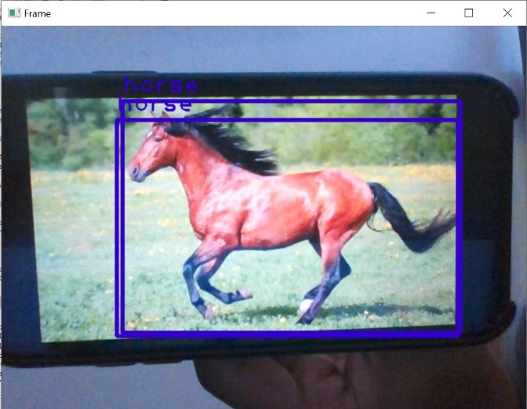
Fig. a output of object detection and tracking


Fig b. Output of object detection and tracking

Fig a and Fig b is representing outputs Object detection which is simply the identification and localization of all items in a scene that are known The task of object detection in videos involves identifying an object's presence in a series of images and potentially pinpointing its exact location for identification.

Fig c Output of Audio Recognition
Fig c is representing output of Audio recognition technology is utilized to automate the video recording process. By recognizing a specific audio signal, the system triggers the recording option, eliminating the need for human intervention.


Fig d Output of Automatic Video Uploading and live with AWS s3
Fig d is representing output of automatic video uploading and live with AWS s3 in which we are creating an S3 bucket where you will store the live video recordings. Configure your video recording device or software to stream the live video content directly to the S3 bucket. You can use an S3 endpoint URL to stream directly to S3 or use Amazon CloudFront to deliver the video stream from S3 to viewers.

CONCLUSION
The paper successfully combines object detection, audio recognition, and cloud-based video storage and streaming capabilities. The automation of video recording and live streaming reduces the need for manual intervention, enhancing the efficiency of the overall system. The integration with AWS S3 provides a scalable and reliable solution for storing and delivering video content. It's crucial to remember that a number of variables, such as the precision of object identification, the dependability of audio recognition, and the efficiency of the AWS S3 integration, affect how well the paper performs.

References
- Lizzy Bleumers,Wendy Van den Broeck, Bram Lievens, and Jo Pierson. 2012. Seeing the Bigger Picture: A User Perspective on 360° TV. In Proceedings of the 10th European Conference on Interactive TV and Video (EuroITV ’12). lACM, New York, NY, USA, 115–124. https://doi.org/10.1145/2325616.2325640
- Terrance E. Boult. 1998. Remote Reality via Omni-Directional Imaging. In ACM SIGGRAPH 98 Conference Abstracts and Applications (SIGGRAPH ’98). ACM, NewYork, NY, USA, 253. https://doi.org/10.1145/280953.282215
- David Frohlich, Allan Kuchinsky, Celine Pering, Abbe Don, and Steven Ariss. 2002. Requirements for Photoware. In Proceedings of the 2002 ACM Conference on Computer Supported Cooperative Work (CSCW ’02). ACM, New York, NY, USA, 166–175. https://doi.org/10.1145/587078.587102
- Karen Holtzblatt, Jessamyn Burns Wendell, and Shelley Wood. 2004. Rapid Contextual Design. Morgan Kaufmann, San Francisco, CA, USA.
- Giulio Jacucci, Antti Oulasvirta, Antti Salovaara, and Risto Sarvas. 2005. Supporting the
- Shared Experience of Spectators Through Mobile Group Media. In Proceedings of the 2005 International ACM SIGGROUP Conference on Supporting Group Work (GROUP ’05). ACM, New York, NY, USA, 207–216. https: //doi.org/10.1145/1099203.1099241
- Tero Jokela, Jaakko T. Lehikoinen, and Hannu Korhonen. 2008. Mobile Multimedia
- Presentation Editor: Enabling Creation of Audio-visual Stories on Mobile Devices. In Proceedings of the SIGCHI Conference on Human Factors in Computing Systems (CHI ’08). ACM, New York, NY, USA, 63–72. https://doi.org/10.1145/1357054. 1357066 https://www.proquest.com/openview/4fbe1deb1c63d536648ee24f4bd0adc0/1?pqorigsite=gscholar&cbl=18750&diss=yv
- Ito, Y., Kikuchi, M., Ozono, T., & Shintani, T. (2021). Developing a Lecture Video Recording System Using Augmented Reality. Developing a Lecture Video Recording System Using Augmented Reality. https://arxiv.org/pdf/2110.05955.pdf
- Dorin Comaniciu and Visvanathan Ramesh, Robust Detection and Tracking of Human Faces with an Active Camera. IEEE Visual Surveillance,2011. [2] Dmitry Mikhaylov, Anton Samoylov, Peter Minin and Alexey Egorov, Face Detection and Tracking fromImage andStatistics Gathering. IEEE Conference on Signal-Image Technology and Internet-Based Systems, 2014. McIvor, “Background subtraction techniques,” in Proc. of Image and Vision Computing, New Zealand, November, 2000.
- M. Piccardi, “Background subtraction techniques: a review,” in Proceedings of the IEEE International Conference on Systems, Man and Cybernetics, vol. 4, (The Hague, The Netherlands), October 2004.
- Satheesh N. et al: Biological Feature Selection and Classification Techniques for Intrusion Detection on BAT, International Journal of Wireless Personal Communications, 09 July 2021.
- Satheesh N. et al: An Enhanced Trust-Based Kalman Filter Route Optimization Technique for Wireless Sensor Networks, International Journal of Wireless Personal Communications, 17 May2021.
- Satheesh N. et al: Flow-based Anomaly Intrusion Detection using Machine Learning Model with Software Defined Networking for OpenFlow Network, Journal of Microprocessors and Microsystems, October 2020.
- Satheesh N. et al: Trust Based Ad Hoc On Demand Distance Vector Routing Protocol Against Wormhole Attack, Journal of Theoretical and Applied Information Technology, December 2014. Vol.70 No.3 – 2014.
- Satheesh N. et al: Evaluation Performance of Worm-Hole Attack Using Proposed AODV in MANET, International Journal of Applied Engineering Research, Volume 11, Number 5 (2016) pp 3282-3288.
- Satheesh N. et al: PREDICTION OF AUTO-DETECTION FOR TRACKING OF SUB-NANO SCALE PARTICLE IN 2D AND 3D USING SVM-BASED DEEP LEARNING, Journal of Theoretical and Applied Information Technology, 2023, 101(5), pp. 1961–1971.
- Satheesh N. et al: Effective Scheduling of Multi-Load Automated Guided Vehicle in Spinning Mill: A Case Study, IEEE Access, 2023, 11, pp. 9389–9402.
- Satheesh N. et al: Design of Automotive Accident-Avoidance System at Speed Limit Zone Using GPS, Lecture Notes in Networks and Systems, 2022, 385, pp. 271–279.
- Satheesh N. et al: IDS detection based on optimization based on WI-CS and GNN algorithm in SCADA network, Lecture Notes in Networks and Systems, 2021, 196, pp. 247–265.
- Satheesh N. et al: Certain improvements to location aided packet marking and DDoS attacks in internetJournal of Engineering Science and Technology, 2020, 15(1), pp. 94–107.
- Satheesh N. et al: Improvements in cluster-based routing to protect malicious node attacks on taodv routing protocol using MANET, Applied Mathematics and Information Sciences, 2019, 13(6), pp. 899–911.
- Satheesh N. et al: Optimizing joins in a map-reduce for data storage and retrieval performance analysis of query processing in HDFS for big data, International Journal of Advanced Trends in Computer Science and Engineering, 2019, 8(5), pp. 2062–2067.
- Satheesh N. et al: Secured wireless sensor network framework to support guaranteed successful data transmission, Applied Mathematics and Information Sciences, 13(2), pp. 209-214.
- Satheesh N. et al: Brain Tumor Prediction using Adaptive Connected Component based GLCM and SVM Method, International Journal on Recent and Innovation Trends in Computing and Communication, 2023, 11, pp. 485–491.
- Satheesh N. et al: BIG DATA FATAL ROLE IN BUSINESS PROCESS OPTIMIZATION USING DIFFERENT ML APPROACHES, 1st -International Conference on Recent Innovations in Computing, Science & Technology, ISBN:978-81-963209-0-4.
- Satheesh N. et al: A Survey on Micro-ElectroMechanical Systems for WSN Hole Using Optimized Sensor Treatment, 1st -International Conference on Recent Innovations in Computing, Science & Technology, ISBN:978-81-963209-0-4.
- Satheesh N. et al: An Autonomous Multi-Modal System Based on Recognized Driving Behaviour for the Neural Internet of Transportation, 1st -International Conference on Recent Innovations in Computing, Science & Technology, ISBN:978-81-963209-0-4.
- Satheesh N. et al: An ML Ensemble Method on Fake News Detection in Social Media, 1st -International Conference on Recent Innovations in Computing, Science & Technology, ISBN:978-81-963209-0-4.
- Satheesh N. et al: Big Data From the Standpoint of a Machine Learning Approach, Science & Technology, ISBN:978-81-963209-0-4.

